Adaptation
Adaptation — A trait, or integrated set of traits, that increases the fitness of an organism.

More specifically --
"…a phenotypic variant that results in the highest fitness among a specified set of variants in a given environment." - Reeve & Sherman 1993

Generally speaking, adaptations are traits or characters that appear to be too well-fitted to their purpose to have arisen by chance. That is, they must be the result of selection.

Adaptations may involve morphological, physiological or behavioural traits. They arise through the accumulation of a series of small improvements over time.

"If it could be demonstrated that any complex organ existed which could not possibly have been formed by numerous successive slight modifications, my theory would absolutely break down." — Darwin.

Examples of Complex Adaptations: the eye; bird wings; the human brain; homeothermic temperature regulation; human language.

But simple traits can also be adaptations.
Example: A single change in allele for wing color in forest-dwelling moths (from black to white). This renders individuals cryptic in brightly lit environments and on pale barked trees. They survive better than black-winged moths in a novel environment -- the forest edges -- and move into this new habitat.

Temperature Regulation in a Bee Hive
The reproductive success of every bee (genus: Apis) in a hive hinges upon the survival of the brood, which are very sensitive to temperature during development. Larvae develop properly between the narrow temperature range of 32-36◦ C. Despite this, bee colonies often survive in extremely adverse environments.
- 5500 m in Himalayas, at low temperatures -50◦ C
- 60◦ C heat, direct summer sunlight, over a lava field

Mechanisms for Temperature Regulation
(behavioural adaptations)
- Hive Location — aerial in warm climates, within shelters in cold climates
- Hive Orientation — entrance always faces south in northern climates
- Heat Production — metabolic heat produced by flight muscles as bees rapidly vibrate wings inside the hive
- Insulation — "clustering" — a living blanket surrounding the hive (begins at ambient temperatures of ~18◦ C)
- Cooling Regimen -
- adults spread out in the hive
- ventilation - bees open holes in the hive during the day
- adults line up in rows, facing away from entrance, and fan air out of the hive with their wings
- evaporative cooling — water spread about hive and over cells containing larvae; increased foraging for water
- partial evacuation of hive if necessary
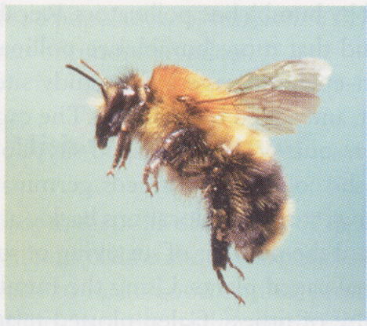
Adaptations are not always obvious, or easy to identify.
In order to identify a trait as an adaptation, we must first determine (or suggest) its use or function, and then show that the trait is advantageous. This can be difficult to do.
Example: The White Coat of Polar Bears
- Hypothesis — white coat is an adaptation for camouflage
- Test — observe hunting behaviour and assay use of camouflage
- Result — camouflage not usually important in hunting
- New Hypothesis — white coat is an adaptation for trapping solar heat
- Test — hairs are actually clear and translucent, and trap 16% of incident light energy
- Compare heat-trapping ability of multiple hair types. Is polar bear fur better than others? YES

Although at first it might have seemed obvious that a white coat is an adaptation for camouflage, it seems polar bears would often be just as successful at hunting if their coat were not white. Their coat does keep them warmer than other coat types, however.
We can suggest adaptive reasons for virtually any trait. The challenge is to show that the trait actually confers the advantage that we’ve suggested.

Studying Adaptation

First, develop alternative hypotheses about a trait's function.
Then, test these alternatives. There are several ways to do this:

1. Observational studies
2. Experiments
3. Theoretical models
4. Comparative method

Each of these methods has advantages and limitations.

Experimental studies
Ex. Wing marks & wing waving in Tephritid flies.

Tephritid flies have dark bands on their wings and wave their wings when disturbed in a manner that is reminiscent of their major predator's territorial display -- e.g., jumping spiders' leg waving.

Do flies mimic their predators?
If so, is this mimicry to deter any predator, or is it specifically to deter jumping spiders?

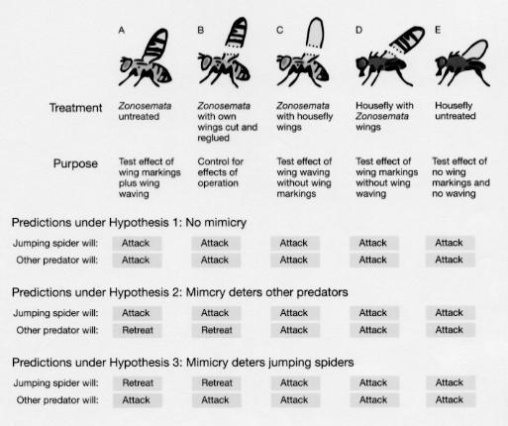

Theoretical models of adaptation

Theoretical models generally fall into two classes. These differ primarily in the form of selection they assume.

- Optimality models -- the fitness of a phenotype is independent of the phenotype of others in the population (frequency independent).

Exs. Temperature regulation, egg size

- Evolutionarily Stable Strategies (ESS) models -- the fitness of a phenotype is affected by the phenotype of others in the population (frequency dependent).

Exs. Animal fighting, parental care

The Comparative Method
Ex. Testis size in bat species.
Male bats vary in the size of testes. One hypothesis for this variation is that large testes produce more sperm, an advantage in sperm competition.
Sperm competition might be more intense in larger social groups, where more males compete for reproductive access to females.

Hypothesis: Testis size is larger in species with larger social groups.
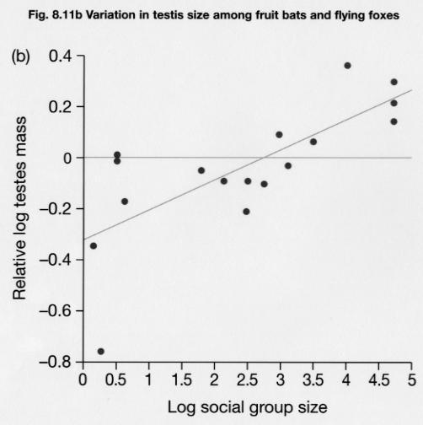

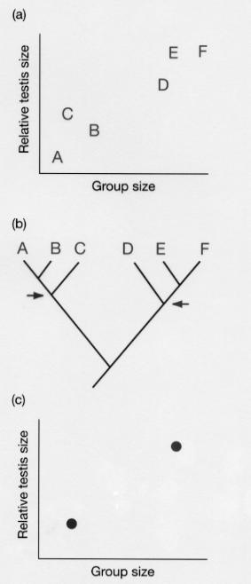 | But not all data points are independent.  Closely related species might have similar group size and testis size NOT because of sperm competition, but because they share an ancestor who had large testes and lived in large groups.  How do we control for the effects of shared history?

Independent contrasts
Compare sister taxa: when they diverge from a common ancestor, do species that evolve larger group size also evolve larger testis size?
1. Need phylogeny
2. Calculate contrasts between sister taxa
3. Evaluate relationship with phylogenetically-corrected values.

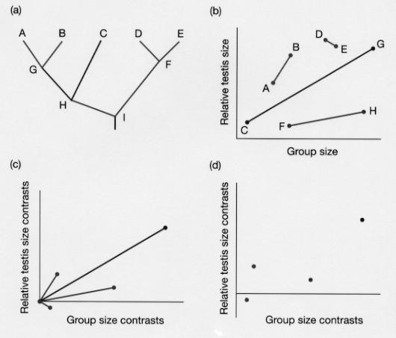
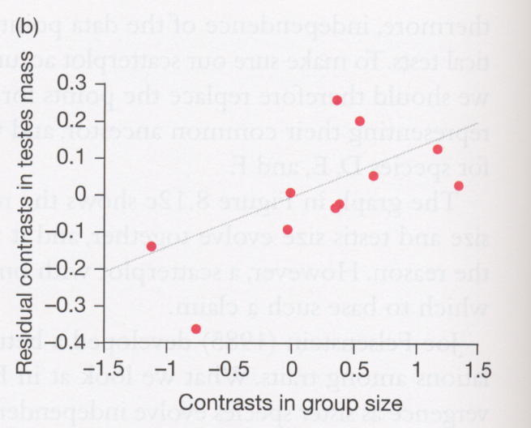

Yes, males in species with larger group sizes also have larger testes.

Adaptations are not perfect -- Constraints to adaptive evolution
Species are constantly evolving and refining their adaptations, as natural selection favours individuals best suited to their environment in each generation. A number of selective constraints prevent adaptations from every being perfect.

Ex. Vertebrate mouths are used for both feeding and breathing. Vertebrates can’t breathe and swallow at the same time, or they choke.

Time Constraints
Evolution takes time (sometimes a lot of it!). Adaptations can be considered "works in progress". Often there simply hasn’t been enough time for evolution to fine-tune adaptations.

Example: Neotropical Anachronisms
Many flowering plants produce fruit to entice animals to disperse their seeds. Fruits need to be attractive to the animals, protect the seeds, and remain in the gut long enough to allow for dispersal of the seeds.
Some trees in the tropical forests of Costa Rica produce very large fruits in great numbers, which are largely inedible to local fauna.
Janzen and Martin suggest these fruits were adaptations to now extinct large herbivores that lived in the area up until about 10,000 years ago. Large fruits would have been attractive to large herbivores, and their hard exteriors would have helped to protect the seeds from being crushed by the herbivores’ teeth.
10,000 years hasn’t allowed enough time for the trees to evolve fruits better suited to the smaller mammals remaining today.
Genetic Constraints
We have seen that when a locus is under selection involving heterozygote advantage, the population evolves to an equilibrium where all three genotypes (AA, Aa, aa) are present. This represents a genetic constraint on adaptive evolution, since homozygotes will always be imperfectly adapted, yet remain in the population.

Example: Sickle Cell Anemia
Homozygotes can have very poor fitness, but remain at appreciable frequencies in populations where malaria acts as a selective agent.

If a new mutation were to arise which allowed malaria-resistance without sickling of the cells, it would likely spread through the population.
Developmental Constraints
Developmental Constraint — "a bias on the production of variant phenotypes (i.e. a limitation on phenotypic variability) caused by the structure, character, composition or dynamics of the developmental system." — Maynard Smith et. al.

The developmental system influences the types of mutations that can occur. Pleiotropy (genes having multiple effects) may require that adaptation of one trait occurs along with changes in another trait.

NOTE: The overall effect a mutation has on fitness is what selection operates on.

Example: Australian Sheep Blowfly (Lucilia cuprina)
Farmers sprayed insecticide, and blowflies soon evolved resistance to it. The mutation conferring insecticide resistance also disrupted the developmental system, producing asymmetry which is maladaptive. Strong selection for insecticide resistance lead to increasing developmental asymmetry.

Over time, mutations at other genes ("modifier loci") evolved to restore symmetry, while maintaining insecticide resistance. The developmental system adjusted to the necessity of carrying the mutation conferring insecticide resistance.
Note that in cases where selection for one trait is not this strong, adaptation of one trait may be difficult if it requires a maladaptation of another trait. (More on trade-offs in a moment)
Historical Constraints
"You can only work with what you’ve got."

For historical reasons, organisms may lack genetic variation that would be adaptive.

In the case of heterozygote disadvantage, populations will fix for one allele (A or a). Which allele fixes depends on :
  - The relative fitnesses of the genotypes.
  - The initial allele frequencies.

The initial allele frequencies represent a historical constraint. Even if fixation for A would lead to higher fitness, a may rise to fixation if the initial allele frequency of A is below the unstable equilibrium point.

Example: The Recurrent Laryngeal Nerve
- 4th vagus nerve first evolved in fish-like ancestors
- successive branches pass behind arterial arches between the gills of fish
- in modern mammals, the nerve passes from the brain, down the neck, around the dorsal aorta and then back up the neck to the larynx
- this detour seems silly in humans, and ridiculous in the giraffe
- mutations generating a more direct route might be beneficial, but are unlikely to evolve since they would involve extensive changes in embryological development

Trade-offs
Traits often serve multiple functions, and genes often have multiple effects. Often the value of one trait in not independent of the value of another trait.

Trade-offs arise when a limited resource (like energy or time) is divided among multiple functions.
Ex 1. Allocating energy to growth or reproduction.

Ex 2. Allocating time to foraging or avoiding predators.

Trade-offs can also arise when becoming better at one thing precludes being good at something else.
Ex. Plankton feeders cannot simultaneously be good at feeding on large aquatic insects.

Traits evolve in response to selection on all of their functions, achieving the best possible overall fitness.
Example: Threespine Sticklebacks (Gasterosteus aculeatus)
Male sticklebacks establish territories in the spring, defend them from intrusions by other males, and court females. Male sticklebacks develop either black or red bellies during the mating season.
Males with red bellies are more successful in securing and defending territories.
- Females prefer to mate with males with red bellies.
Breeding experiments show that the colour of male bellies is controlled by a single locus with two alleles (black and red). Why then does the black allele remain in the population?
- Sticklebacks sometimes share habitats with mudminnows, which secure territories earlier in the season.
- Mudminnows have black bellies.
Male sticklebacks with black bellies are more successful in acquiring territories from mudminnows. Female sticklebacks will only mate with males that have nest territories.
A trade-off exists between success at intraspecific competition and interspecific competition.

Summary
Adaptations (especially complex ones) evolve through a series of small changes over time.

- Studying adaptations requires posing and testing alternative hypotheses about trait function and its effects on fitness.

- Adaptations need not be perfect. The are continually evolving through natural selection to better fit the current environment.

- Constraints limit the types of adaptations that evolve, and include time constraints, genetic constraints, developmental constraints and historical constraints.

- Trade-offs between positive and negative implications of modifying a trait can constrain adaptive evolution.

