Biology 413 (Zoogeography) Final Exam [PRACTICE]
Winter Term 2 - 2020
Directions:
- Write your name and student number on each page of the exam.
- All answers should be written in the space provided. If you need extra space, you can use extra paper, but clearly label your answers.
- The exam is designed to be completed in 2.5 hours.
- The exam questions are organized into two parts and consist of six pages.
- PART I consists of 10 short-answer questions.
- PART II consists of three long-answer (essay-form) questions.
Points
PART I: 34 points
PART II: 40 points
TOTAL: 74 points

PART I
Answer the following 10 questions using 2-3 sentences or less. Please use the space provided.
Question 1 [3 points]: Define the target effect and the rescue effect, in the context of the equilibrium theory of island biogeography.

Question 2 [4 points]: The figures below show the species area relationship (left) with two lines representing two sampled areas (circle groups, A and B, right). Species richness is documented within groups A and B in circles with increasing habitat area. Group A represents samples from areas of continuous mainland habitat. Group B represents samples from isolated oceanic islands. Which species area relationship in the left figure represents each circle group? Label each line as A or B. Explain your reasoning in the space provided.
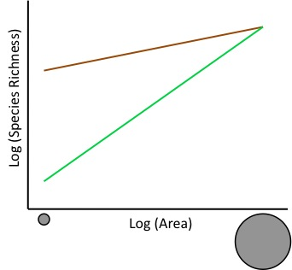

Question 3 [4 points]: What does it mean for a community to be phylogenetically overdispersed or clustered? What ecological processes can generate patterns of phylogenetic overdispersion or clustering?

Question 4 [3 points]: What phylogeographic inference can be made to explain the congruent discontinuities in distributions of these four distinct groups, shown in the figure below? In other words, what could generate similar phylogeographic patterns across various taxa?
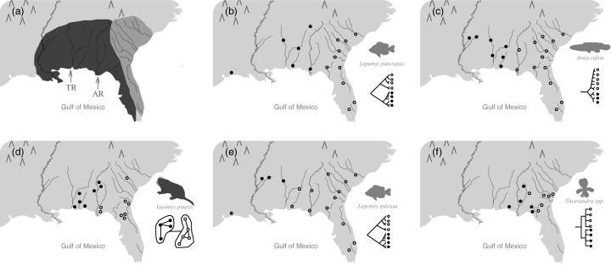

Question 5 [3 points]: Endemic species are sometimes described as “relicts”. What is the difference between taxonomic and biogeographic relicts?

Question 6 [3 points]: What is a “climate envelope” and how is it used to predict changes in species distributions with climate change?

Question 7 [4 points]: Define alpha diversity and beta diversity. How does each of these measures capture different components of species diversity within ecological communities?

Question 8 [3 points]: In the context of conserving biodiversity and evolutionary history, describe the basic motivation for conservation based on evolutionarily significant units (ESUs) and evolutionarily distinct and globally endangered (EDGE) species.

Question 9 [3 points]: Some argue that the current extinction crisis represents Earth’s sixth mass extinction. What two metrics are used to assess or quantify a mass extinction and what do they measure?

Question 10 [4 points]: Provide a brief definition for the three “shortfalls” (Wallacean, Linnaean and Hutchinsonian) with respect to predicting changes in species distributions.

PART II

Answer the following questions using the space provided, with complete sentences as necessary.

Question 11 [10 points]: The figure below shows the representation of species on an island by: 1) Non-endemic species (i.e., species also found on the mainland); 2) Endemic species, found only on the island; and 3) In situ clades (endemic species that have diversified within the island).
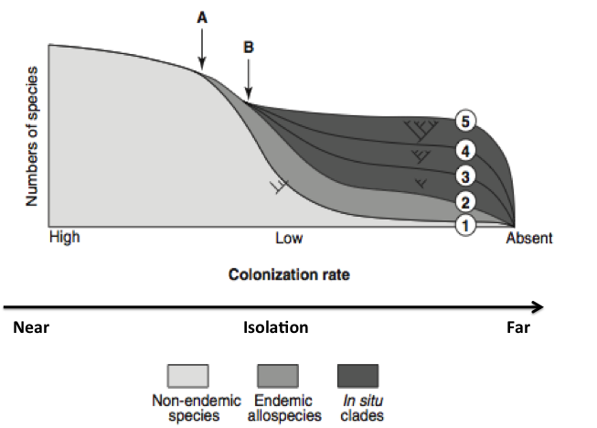

In the space provided below, write a comprehensive figure legend that explains the shift in representation of the three species groups as colonization rate decreases and isolation increases. Be sure to define the axes, the different shaded areas, and the expected changes across communities represented by 1 - 5.
PART II (continued)
Question 12: We have discussed Janzen’s hypothesis with respect to several different themes in biogeography. Describe the predictions derived from Janzen’s hypothesis for tropical and temperate mountains and/or montane species with respect to the following: (1) physiological barriers to dispersal; (2) breadth of elevational ranges; (3) beta diversity (or change in species composition) along elevational gradients; (4) potential for allopatric speciation and (5) sensitivity of species to climate warming.
[3 points each – 15 points total]

PART II (continued)
Question 13: The latitudinal gradient in species diversity is sometimes considered the only true law in biogeography. Explain what this gradient is (3 points) and provide a discussion of four major hypotheses to account for it (including their weaknesses or exceptions to the general patterns; 3 points per hypothesis). We discussed more than four hypotheses in class, but choose four among those presented. You may use illustrations to help make your points. [15 points total]

