**Biology 413 (Zoogeography) Final Exam**

**Winter Term 2 - 2020**

**Directions:**

1. **Type your name and student number on the first page of the exam (using the Header).**
2. **IMPORTANT: Limit your typed answers to the space provided (using 12pt Times New Roman font). Your exam must not exceed 10 pages (answers extending beyond 10 pages will not be marked).**
3. **You have four days to complete this take home exam (but the exam is designed to be completed in 2.5 hours). You are allowed to use your notes, powerpoint slides, or online material, but make sure your answers are in your own words.**
4. **The questions are organized into two parts and consist of nine pages.**
5. **PART I consists of 9 short-answer questions. PART II (questions 10-13) consists of multi-part and long-answer (essay) questions. Answer questions 10-13 using complete sentences.**

**Points**

**PART I: 36 points**

**PART II: 52 points**

**TOTAL: 88 points**

**PART I**

**Answer the following 9 questions using fewer than 5 sentences.**

Question 1 [4 points]: The figures below show the species area relationship (note the log scale) with two best fit lines representing two different groups: triangles show lakes found in North America and circles show lakes in Africa. The North American lakes were formed <10,000 years ago, following glacial retreat, whereas African lakes are considerably older (>1 million years).

What may explain the difference in slopes of these relationships? Why are the largest differences found between large lakes in North America and Africa?

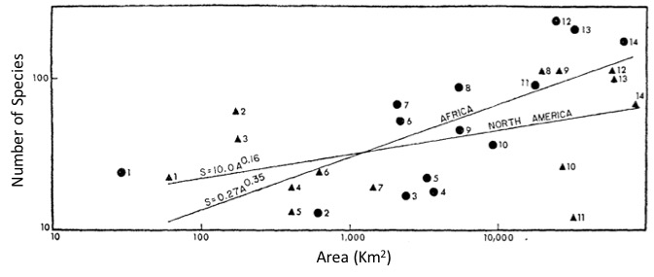

**PART I continued**

Question 2 [4 points]: The emergence of the Central American land bridge, which joined the North and South American continents, resulted in the Great American Biotic Interchange. But in mammals, this exchange of species was asymmetric; more species colonized South America from the north than colonized North America from the South. What is one reason for this asymmetry? Explain your answer.

Question 3 [2 points]: The distribution-abundance hypothesis states that there is a positive correlation between species’ abundance and distribution. Why is this relationship especially important for endemic species, as it relates to extinction risk?

Question 4 [4 points]: There are multiple lines of evidence to support the theory of continental drift. Describe two of these lines of evidence.

Question 5 [3 points]: What is a “climate envelope” and how is it used to predict changes in species distributions with climate change?

**PART I continued**

Question 6 [3 points]: Provide a brief definition for the three “shortfalls” (Wallacean, Linnaean and Hutchinsonian) with respect to predicting changes in species distributions.

Question 7 [4 points]: Extinctions are often preceded by predictable patterns in range collapse. Explain how this is shown in the figure of native bird species distributions on the island of Kaua’i over time. What is a probable cause associated with this pattern of population decline? [Hint: study the map to understand which areas native birds are being restricted to]

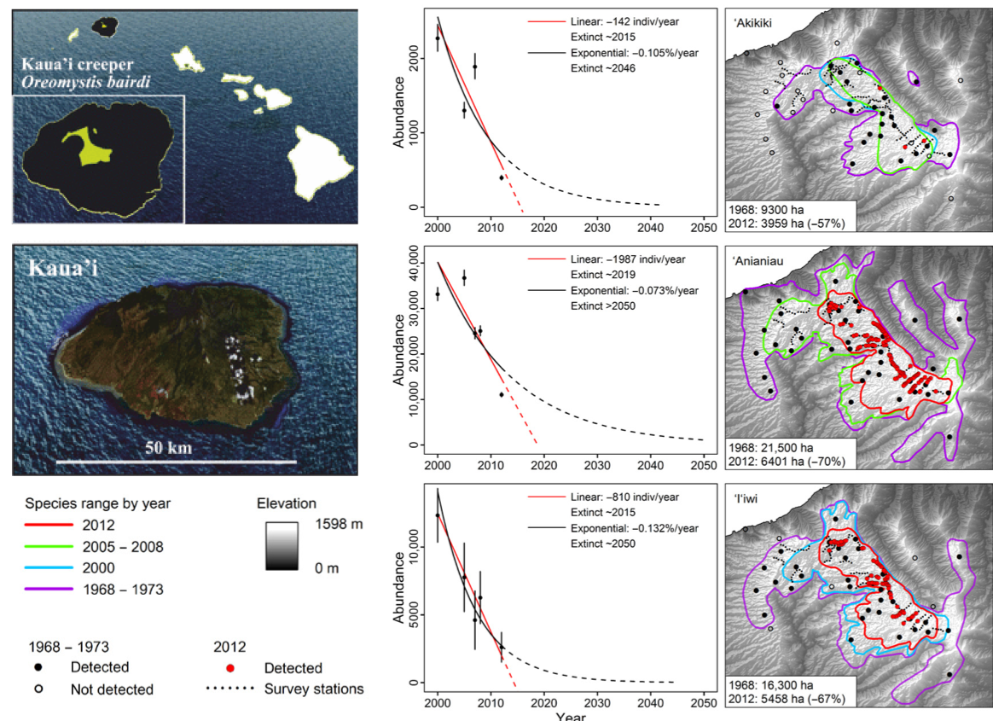

**PART I continued**

Question 8 [6 points]: The figure below shows a map of the state of Florida, which forms a peninsula at the southeastern most extent of the North American continental landmass (the reference map shows the position of Florida and an overall gradient in mean range size for other taxa in North America).

Peck and colleagues (2005) mapped ground beetle diversity across latitudinal zones of the Florida peninsula (zones shown as roman numerals on the map). They found the following patterns when they examined the richness of: (a) all species, (b) temperate species, (c) tropical species and (d) species endemic to Florida (note the different scales on the y-axis).

Using concepts and principles you have learned from island biogeography, diversity gradients, and speciation explain these different richness patterns for the beetle groups shown in a), b), c) and d).

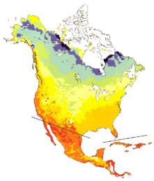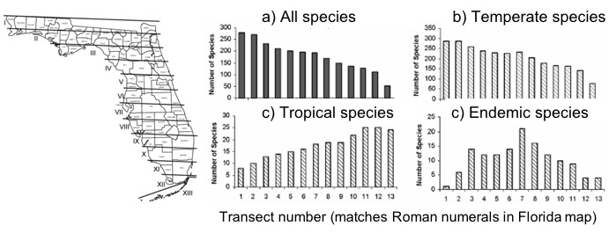

**PART I continued**

Question 9 [6 points]: The figure below shows four idealized patterns of species distributions along an environmental gradient [A-D] proposed in Whittaker (1975) *Communities and Ecosystems*. Explain the abiotic and/or biotic forces that species experience in each community, which are likely to result in the four distinct patterns [1.5 points each].

**PART II**

**Answer the following questions using the space provided, with complete sentences as necessary.**

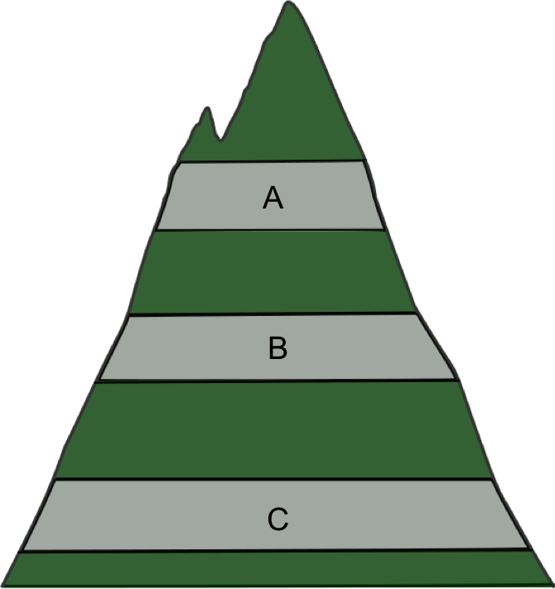Question 10 [14 points]: The figure to the left shows a mountainside with biological communities (e.g., birds, insects, or trees), which are surveyed at each of three elevational bands, labeled A, B and C (grey bars). The phylogenies below (in question 10c) represent species in elevational bands across the mountainside. Use these figures to answer the following:

a) Define alpha, beta and gamma diversity for this mountainside, with respect to elevational bands/habitats A, B and C. [6 points]

b) We expect the phylogenetic structure of communities to change with elevation. Which community (high or low elevation) is more likely to show phylogenetic clustering? Which is more likely to be overdispersed? [2 points]

c) These figures show the species that co-occur in each of one of the three gray elevational zones, which are mapped onto a phylogeny. Place a letter below each of the phylogenies to indicate which elevational zone they should represent (A, B or C)? [3 points].

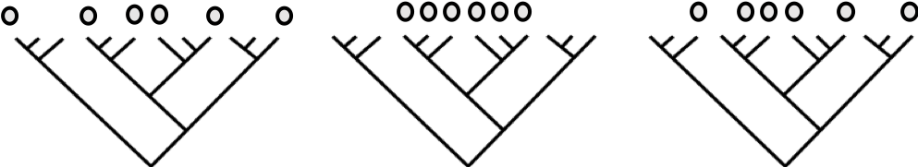

d) Explain your answer in b) and c), highlighting possible ecological or evolutionary processes that could generate the patterns of phylogenetic community structure observed across elevations [4 points].

**PART II continued**

**Answer the following questions using the space provided, with complete sentences as necessary.**

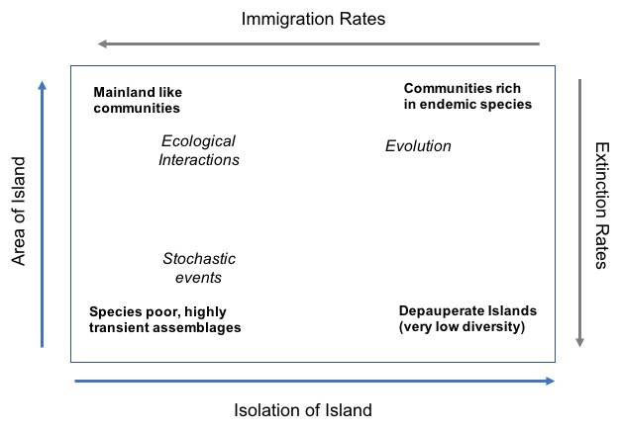Question 11:[12 points] The box below shows four likely assemblages found on islands, one in each corner of the box, which reflects MacArthur and Wilson’s Immigration/Extinction dynamics from the Theory of Island Biogeography.The terms in **bold** describe what kind of communities are most likely to be found on that island. The terms in *italics*describe the dominant processes expected to generate those different assemblages. The arrows at the top and bottom show that from left to right, islands increase in isolation and decrease in immigration rates. The arrows on the left and right of the box show that from bottom to top, islands increase in area and decrease in extinction rates.

For each corner of the box, explain why we see these patterns in *composition* on each type of island, which are shaped by the associated *processes*. Also explain why we see depauperate islands in the lower right-hand corner.

Be sure to relate the terms in each corner to both the area/isolation axes and the immigration/extinction rate axes. Use complete sentences.

**PART II continued**

Question 12 [14 points total]: We have discussed Janzen’s hypothesis with respect to several different themes in biogeography. Interpret the following two figures [6 points] and describe how the data shown are consistent with predictions derived from Janzen’s hypothesis for diversity patterns in tropical and temperate montane communities and attributes of montane species [8 points]. 

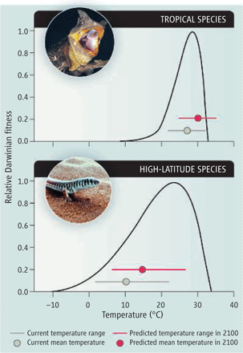

**PART II continued – Final Question**

Question 13: The latitudinal gradient in species diversity is sometimes considered the only true law in biogeography, and various hypotheses have been put forward to account for this pattern. **A number of these hypotheses can also be applied to explain diversity patterns along altitudinal gradients.** Choose three hypotheses that explain the latitudinal gradient in diversity, state what they predict and describe how (and whether) the hypothesis applies to both latitudinal **and** altitudinal gradients in diversity. [4 points per hypothesis – 12 points total].