Zoogeography Assignment 6 Due Mon, Mar 16th, 11:00am

Graham, C. H., Parra, J. L, Rahbek, C., and J. A. McGuire (2009). Phylogenetic community structure in tropical hummingbird communities. PNAS 106: 19673-19678.
Instructions:
- Use your own words and provide complete but concise answers to the following questions
- Cite literature appropriately if referenced.
- Typed answers should not exceed 2 pages (e.g. the front and back of this page).
- Hard copy to be handed in by 11:00am in lecture on Monday Mar ch 16th.

- Use the phylogeny (right) to complete the table (left) so that phylogenetic beta diversity (turnover) is maximized. Each ‘community’ consists of only two species. Assign each species (a, b, c, or d) to only one box. Refer also to page 2, column 1 of Graham et al (2009). [2 pts]
 | Community 1 | Community 2
Species 1
Species 2
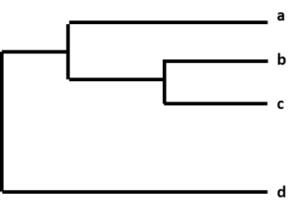
- What does it mean for a community to be phylogenetically clustered or over-dispersed?
[2 pts]

- What characteristics or traits of hummingbirds make them susceptible to the more severe abiotic conditions at high elevations? [2 pts]

- A) In which regions do the authors find phylogenetically clustered communities of hummingbirds? Where do they find over-dispersed communities? [2 pts]

B) Briefly describe how the authors explain the distribution of phylogenetically clustered and over-dispersed communities. [2 pts]

