CONDUCTION VELOCITY OF THE ULNAR NERVE
IN HUMANS.

WORK IN PAIRS.
OBJECTIVES
What is the velocity of impulse propagation of the human's ulnar nerve?

- Equipments -
- oscilloscope
- stimulator and SIU unit
- 6 volts battery
- pulse generator
- hand-held stimulating electrode
- redux paste
- amplifier
- disposable adhesive recording electrodes
- ball point pen or marker
- ruler

Nerve conduction velocity in human can be easily determined by stimulating a motor nerve and measuring the time it takes for its associated muscles to contract.
The time interval between the stimulation and the response - latent period - is recorded from two different points along the nerve. The difference between the two latent periods is the time required for the nervous impulse to travel from point A to point B.

In this exercise you will stimulate the ulnar nerve and record muscle contractions in the fifth finger.

I. THE SET UP (figure 1).

Stimulation of the ulnar nerve.

The Ulnar nerve is stimulated with the hand held electrode.

The Pulse Generator, fed by a 6 volts battery, sets the intensity of the voltage delivered to the stimulating electrode.

In this experiment, the STIMULATOR sets the duration and the frequency of the stimulus delivered by the electrode. The stimulator is equipped with several controls:
The pulse switch allows the delivery of a single pulse or the delivery of twin pulses (two consecutive shocks one after the other at pre-set intervals, where the time lapse between the two shocks is regulated by a time delay switch.). LEAVE IT ON SINGLE PULSE.
The delay sets the time separating the two shocks when the pulse switch is in the twin pulses mode. DON'T WORRY ABOUT IT!
The amplitude sets the intensity of the stimulus pulse, measured in volts. For the regulation of the amplitude of the stimulus a Stimulus Isolation Unit (SIU) is connected to the system. The SIU ensures that a “square wave” pulse is generated, which simply means a pulse of the same intensity throughout its duration. When a Stimulus Isolation Unit is connected, the voltage on the stimulator is set at the 10X SIU setting and the range is regulated via the SIU unit.
Remember: with this set up, the intensity of the stimulus delivered to the subject via the electrode is sets by the pulse generator (NOT by the stimulator). This means that the intensity of the stimulus delivered by the stimulator has to be strong enough to trigger the release of a stimulus from the pulse generator. IN THIS EXPERIMENT, a minimum of 20 volts is required to operate the pulse generator.

The duration sets the time each pulse of the stimulator lasts.
The mode switch allows a single delivery of a single pulse (or of twin pulses) or the delivery of volley of single pulses (or twin pulses).
The frequency sets the number of single pulse (or twin pulses) delivered per second.

To obtain proper results it is important that all the parameters of the stimulus be correctly set. Please note that the frequency, voltage, and duration dials on your stimulator are of limited range.
Below some of these dials there is an additional switch, which multiplies the readings by various factors. Your final setting will be a product of the dial reading and the setting of the multiplication switch.

Recording of muscle contraction in the fifth finger (Electromyogram: EMG).

Muscle contraction in the fifth finger is picked up with an adhesive disposable recording electrode. The signal is then amplified with an amplifier before being sent and read on an oscilloscope.

II. LOCATION OF THE ULNAR NERVE (figure 2).

The ulnar nerve descends on the inner side and along the arm toward the elbow. Then, it swings behind the medial epicondyle of the humerus ("funny bone") and then follows the inner side of the ulna toward the wrist. It ends up innervating the 4th and 5th digits of the hand.

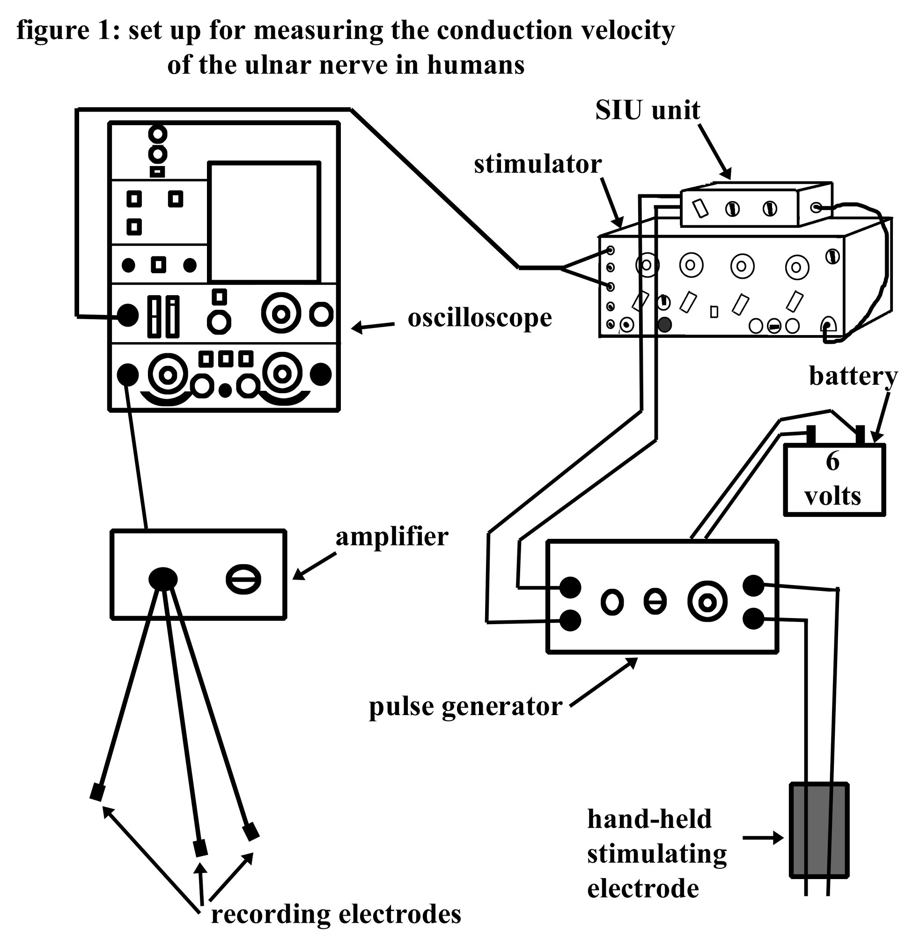
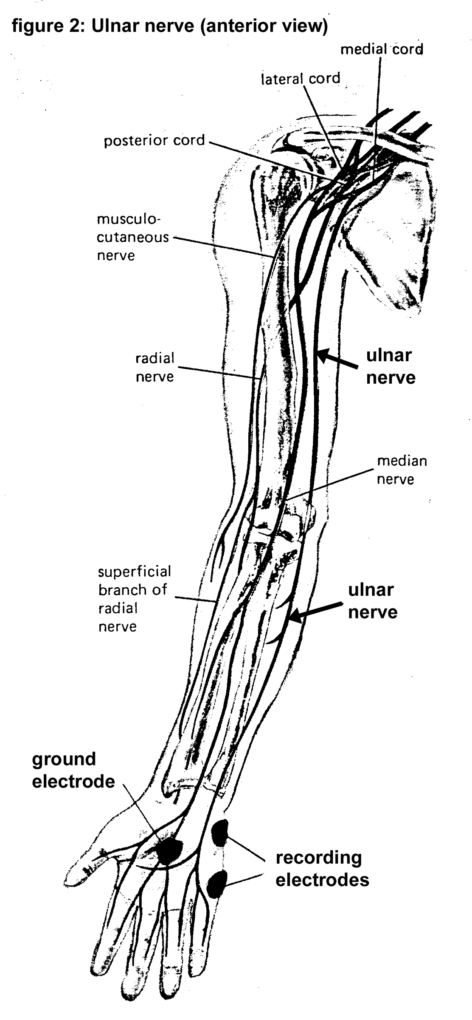
III. What is the velocity of impulse propagation of the human's ulnar nerve?

- Experimental procedure:

Stimulation of the ulnar nerve.

1. Set Grass stimulator to a frequency of 1/sec.; duration of 20 msec. and stimulus mode to repeat. Set the stimulator to deliver the voltage indicated on the pulse generator. The required voltage will vary from unit to unit (Set voltage on 10 X multiplication range).

2. Make sure to connect "sync out" of stimulator to X input of oscilloscope.
NOTE: The electron beam sweep can be triggered internally by the oscilloscope or by a source outside the oscilloscope. This connection will allow the stimulator to trigger the sweep of the electron beam on the oscilloscope each time the stimulator sends an impulse to the stimulating electrode.

3. Connect Grass stimulator output to the battery operated pulse generator,

4. The recording electrodes are disposable and look like round stickers. Stick them on your hand as described in figure 2.
The active and indifferent electrodes should be positioned side by side along the medial border of the hand.
The active electrode is placed midway along the lmedial border of the large muscle above the fifth finger (hypothenar eminence);
The indifferent electrode is placed at the base of the proximal phalanx of the fifth finger,
The ground electrode (green) is placed on the palm surface of the hand.

5. Starting with the lowest setting on the pulse generator touch your arm with the stimulating electrode. Increase the output gradually until you feel a strong muscle contraction of the 5th finger.
NOTE: to insure better contact between the electrode and your skin, dip the two prongs of the electrode in redux paste.

6. Move the stimulating electrode to the approximate location of the ulnar nerve. ALWAYS PLACE THE CATHODE (black) OF THE STIMULATING ELECTRODE NEAREST TO THE MUSCLE BEING STIMULATED. Locate the ulnar nerve at the wrist, elbow and upper arm, by watching for contraction of the little finger. Mark the location of the nerve at these points with a ballpoint pen. Now you are ready to record.

Recording the EMG.

7. Turn the oscilloscope ON, Store "off" (button in an out position). Set triggering source to "line" (or "int."), triggering mode to "norm." (or "auto"), and turn CHANNEL 1 on. (Left hand side control panel, and button to be pushed in.) Use 50 or 100 mvolts/div., a time base of 5 msec/div. Center the beam (it should be a line) in the middle of the screen and have it started on the left side of the screen.

8. Check that the triggering is working: set triggering source to "ext.", triggering mode to "norm.",

NOTE: The oscilloscope should now produce a trace only when the Grass stimulator produces a pulse. If this is not happening, it may be necessary to adjust the trigger level on the oscilloscope.

If no trace at all is visible on your screen, the position of the beam will have to be adjusted in the following manner:
Turn intensity dial fully clockwise, depress beam finder button, centre trace on screen using the vertical and horizontal position knobs. Release beam finder knob and make fine adjustments to position until the complete trace is visible on the screen. Then readjust the intensity to a readable desirable condition.

9. Hook the recording electrodes to the amplifier.

10. Change oscilloscope triggering source to "line" (or "int.") and triggering mode to "norm" or ("auto"). A continuous trace should now be seen. (It may be necessary to readjust trigger level.)

11. Flex the little finger and adjust the gain of the amplifier until substantial trace deflection is seen. Do not proceed until an EMG is observed. If no deflection can be seen on the oscilloscope, check all the connections, particularly the recording electrodes.
NOTE: If you move your arm, the baseline of your trace will shift off screen. Rest your arm on the bench and relax.
To get a better signal, make sure that the cables connecting to the stimulating and recording electrodes do not touch or overlap.

12. Return triggering source to "EXT".

13. Stimulate the nerve at one of the points already marked. When the contractions are satisfactory, store the trace.

NOTE: To use the storage capacity of the oscilloscope, depress the store button and press erase. The screen is empty and each time the stimulator sends its impulse, you should see a trace permanently recorded on the screen of the oscilloscope. The traces will overlap and screen will become crammed very quickly. To erase them push the erase button.

You want to control when traces are to be recorded on the screen: set the triggering mode to "single sweep". Each time you press the triggering mode to reset and let it return to the "single sweep position, one trace will be recorded on the screen.

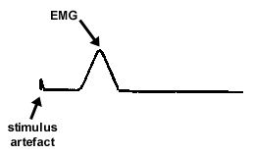
If everything is done properly you should get the following:

The first deflection is the stimulus artefact. The stimulus artefact is an electrical leakage from the stimulating electrodes, which is conducted along the surface of the arm and picked up by the recording electrodes. It may be necessary to adjust the horizontal position for the stimulus artefact to appear on the display. If the artefact trace disappears off scale, and adjusting the vertical position does not bring it back, reduce the sensitivity (Volts/div.).

The second deflection represents the contraction of the muscle (EMG). The time delay between the stimulus and the response represents the latent period. Measure it. To produce a suitable trace it may be necessary to re-adjust the time base or the sensitivity.

14. Repeat at the other two locations on the arm. Measure the time delay between stimulus and response.

NOTE: Try to store all three different traces on a single screen.
- Set oscilloscope triggering mode to single sweep, STORE-on and press erase.
- Hold probe on the first mark on your arm and momentarily depress mode switch to reset. When a trace is obtained, repeat procedure on the next point marked on your arm.

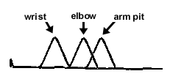
IT IS SOMETIME DIFFICULT TO STORE ALL THREE TRACES ON A SINGLE SCREEN. SO, MAKE SURE THAT YOU RECORD THE LATENT PERIOD FOR EACH RECORDING AS YOU OBTAIN THEM.

Velocity Measurements

15. To calculate conduction velocity, record delay times (msec) from oscilloscope, and measure the distance (on the arm) between the point of stimulus and the first recording electrode. Plot the distance along the nerve vs. time delay. The slope of the line will give the conduction velocity of the nerve impulse in the ulnar nerve. Express this velocity in meters/sec.
OR:
Read time delay between peaks from oscilloscope, and record distance between points of stimulus on the ulnar nerve. To calculate conduction velocity, use the following formula:

Distance between points of stimulus / difference in their time delay = conduction velocity in cm/msec.

Convert the obtained value to meters/sec.

Clean up

- Turn off and disconnect the electronic equipment.
- Leave your space clean and tidy for the next group.

